PHASE 6: Project Testing Phase
Project Team Members
M.G Misriyathul Ibrahima
S.M.B.N Meera Jenira
V.Mohana
P.Mutharasi
S.A.K. Muthu Ameena

Project: Implement Client Script & UI Policy (Incident)
ServiceNow – Incident Management

Phase Objective
To verify that each configured UI Policy and Client Script behaves according to the defined requirements.

Test Case 1 – High Impact and Missing Assigned To
Set Impact to High, leave Assigned To empty, and attempt to submit. Expected behavior: the onSubmit validation prevents saving and displays an error.

Test Case 2 – Successful Save
Provide an Assigned To value and submit the High Impact Incident. Expected behavior: the Incident can be saved and the configured Urgency behavior remains in effect.

Test Case 3 – Reverse Condition
Change Impact from High to Medium. Expected behavior: Reverse if false restores normal field behavior, including making policy-controlled fields editable/not mandatory as applicable.

Test Case 4 – List Edit Blocking
Attempt to change State directly from the Incident list. Expected behavior: the onCellEdit script rejects the change.

Test Case 5 – Form-Based State Update
Open the Incident form and change State there. Expected behavior: the form-based change is allowed.

Testing Summary
The project evidence includes the Incident form and Incident list views used to demonstrate the configured behavior.

Project Evidence – Screenshots
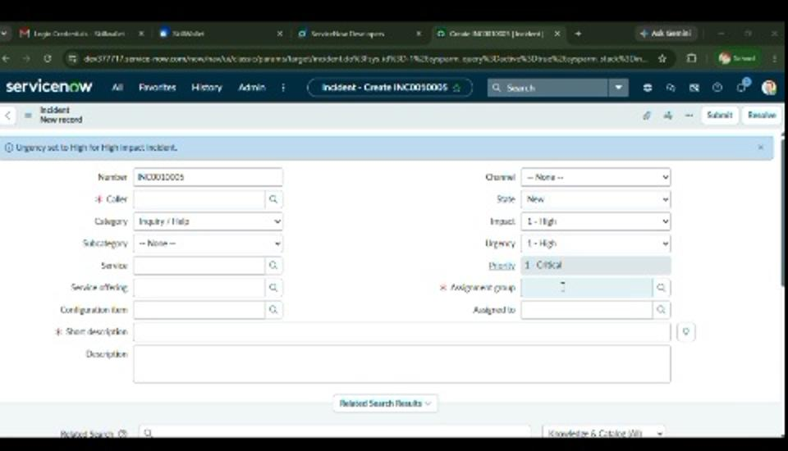
Figure 11. Incident form used for functional testing.
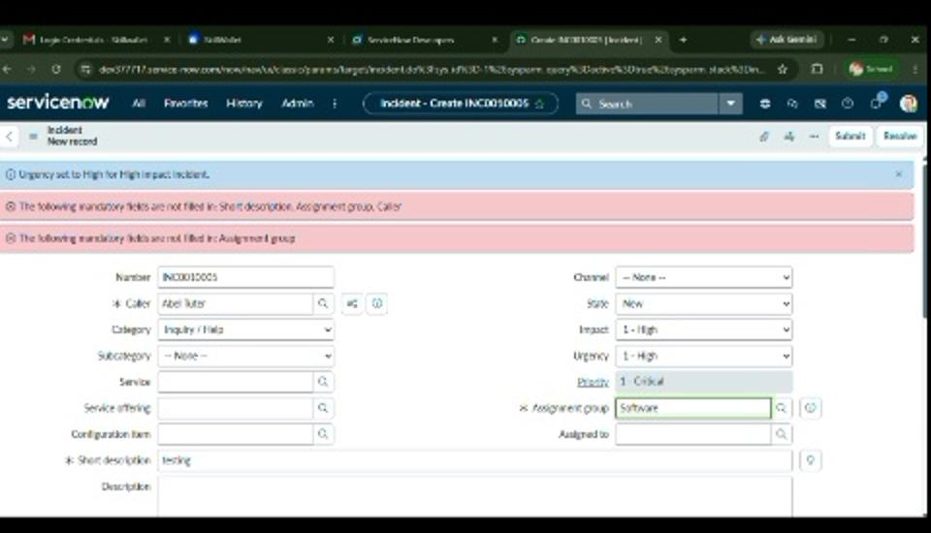
Figure 12. Validation feedback visible during testing.
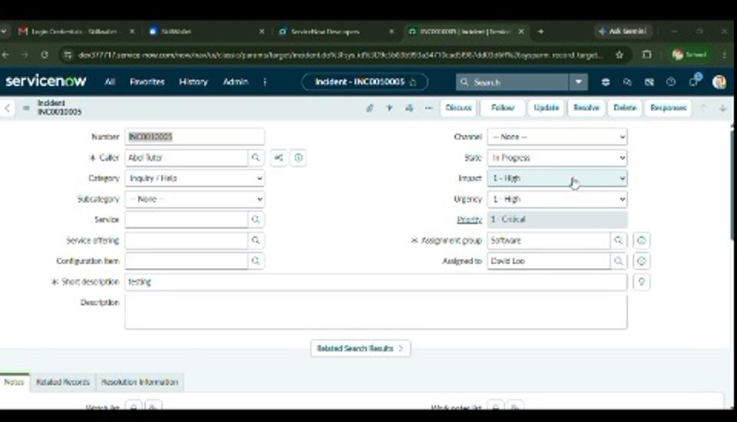
Figure 13. Incident after required information is populated.
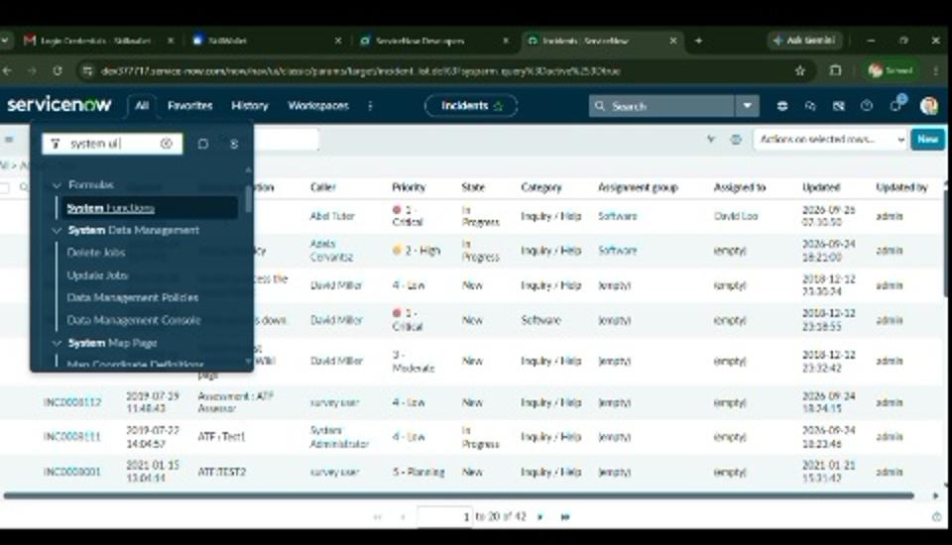
Figure 14. Incident list used for list-edit and record verification.

Phase Outcome
The configured behaviors were checked using High Impact, Assigned To, Urgency, State, and save/list-edit scenarios.

